**T2.B1 Effective Interaction within your Research Team**

**Preparation Part Three**

1. If not done yet, please watch part two of the video explanation about the seven habits:

Part one: <https://www.youtube.com/watch?v=WFc08j9eorQ>

Part two: <https://www.youtube.com/watch?v=5LbCRx1UbWY>

1. Read the theory about Think Win/Win (pg. 2-5)
2. Prepare and execute your case. Make notes about what happened.
3. Think of a (new) case that you want/need to practice with someone within your working environment:

* Describe the context and situation
* Describe your conversation partner (facts, character, typical behaviour)
* Describe your difficulty with this person / the situation
* Describe what should be the goal of the conversation

If you need inspiration, think of:

* Interaction where you find it difficult to say “no” to the other person
* Interaction where you find it difficult to listen to the other person
* Interaction where you don’t understand the other or where you are not fully understood
* Interaction where you find it hard to express your point of view and lose connection
* interaction with someone that is complicated / needs work

1. If you want to experience the meaning and effect of facial expressions, you are invited to watch:

<https://youtu.be/LHraznv4pHQ> and

Haydn Symphony No 88 4th mov Bernstein Wiener Philarmoniker <https://youtu.be/kke4SyaP25c>

**Habit 4**

**Think Win/Win**

Think Win/Win is one of Covey’s habits of interpersonal leadership. It’s not a technique, but a frame of mind and heart that constantly seeks mutual benefit in all human interactions.

**1. Win/Win**

Win/Win means that agreements or solutions are mutually beneficial, mutually satisfying. It is based on the paradigm that there is plenty for everybody, that one person’s success is not achieved at the expense of exclusion of the success of others. It’s not your way or my way; it’s a *better* way, a higher way. With a Win/Win attitude, you stay longer in the communication process, you listen carefully and you express your point of view with courage. Win/Win is one of six paradigms of interaction:

1. Win/Win
2. Win/Lose
3. Lose/Win
4. Lose/Lose
5. Win
6. Win/Win or No Deal

**2. Win/Lose**

Most people have been deeply scripted in the Win/Lose mentality since birth. It interprets an individual’s value by comparing him or her to everyone else: you got an “A” because someone else got a “C”. When you focus on Win/Lose, you define other people extrinsically, meaning that you grade them in relation to other people instead of against their own potential. Certainly there is a place for Win/Lose thinking in truly competitive and low-trust situations. But most of life is not a competition. Most of life is an interdependent, not an independent, reality. Most results that you want depend on cooperation between you and others. The Win/Lose mentality is dysfunctional to that cooperation.

**3. Lose/Win**

Some people are programmed Lose/Win. “I lose, you win.” “Step on me again. Everyone does.” The bad thing of Lose/Win is that is has no standards – no demands, no expectations, no vision. If you think Lose/Win you probably seek strength from popularity or acceptance. You have little courage to express your own feelings and convictions and are easily intimidated by the ego strength of others. In negotiation you choose for giving in or giving up. Often, Lose/Win people bury a lot of unexpressed feelings. Feelings that are buried alive and come forth later in uglier ways, e.g. overreaction to minor provocation, cynicism, disproportionate rage or anger.

**4. Lose/Lose**

Lose/Lose can be the philosophy of avoidance: not interested in reaching goals or in relationships with others. Realize that avoidance of conflict can be positive, but also negative! Lose/Lose can also be the philosophy of adversarial conflict, the philosophy of war: some people become so centered on an enemy, so totally obsessed with the behaviour of another person that they become blind to everything except their desire for that person to lose, even if it means losing themselves. Thus both people lose.

**5. Win**

When you have the Win mentality you don’t necessarily want someone else to lose. That’s irrelevant. You simply want to get what you want. It is probably the most common approach in everyday negotiation. A person with the Win mentality thinks in terms of securing his own ends – and leaving it to others to secure theirs.

It depends which of the five philosophies discussed so far is most effective. If you win a football game that means that the other team loses (Win/Lose). If you value a relationship and the issue isn’t really that important, you may want to go for Lose/Win in some circumstances to genuinely affirm the other person. “Let’s do it your way this time.” When someone is in danger, you may be highly concerned with saving him and not with the relationship to others (Win).

**6. Win/Win or No Deal**

Most situations however, are part of an interdependent reality, and then Win/Win is really the only viable alternative of the five. In the long run, if it isn’t a win for both, you both lose. In his book, Covey goes even further and comes up with the option of Win/Win or No Deal.

No Deal basically means that if you can’t find a solution that would benefit you both, you agree to disagree agreeably. With No Deal as option, you can honestly say, “I only want to go for Win/Win. I want to win and I want you to win”.

**Five dimensions of Win/Win**

Think Win/Win takes great courage as well as consideration to create the mutual benefits, mutual influence and mutual learning you want. It requires a total paradigm of human interrelation and principle-centered personal leadership:

1. Character of **integrity**, **maturity** and the **abundance mentality**

1. Integrity. You have to identify your values and you must make and keep commitments to yourself as well as to others.
2. Maturity. When you express your feelings and convictions, ensure a proper balance between courage and consideration. Understand empathically, confront courageously.
3. Abundance Mentality (instead of Scarcity Mentality). There is plenty for everybody. Be genuinely happy for the success of others, share recognition, credit, power or profit.

2. **Relationships of high-trust**

A Win/Win in relationships means that even though you see things differently, you know that you both are open and willing to listen with respect. When your Emotional Bank Account is high (enough deposits), you trust each other. For this reason it is important to focus on your Circle of Influence and make deposits through genuine courtesy, respect and appreciation for another person and for his point of view.

3. It is embodied in **agreements** that effectively clarify and manage expectations as well as accomplishments. In the Win/Win situation there is a clear mutual understanding and agreement in the following five areas

1. Desired results: what is to be done and when;
2. Guidelines: principles, policies within which results are to be accomplished;
3. Resources: identify the support available to help accomplish the results;
4. Accountability: sets up standards of performance and time of evaluation;
5. Consequences: good and bad, what will happen as a result of the evaluation.

Creating Win/Win performance agreements requires focus on results; not methods. If you have a deep and thorough discussion of expectations, guidelines and resources with your supervisor, if you make sure they are in harmony with organizational goals and if you can indicate when the next performance plan of review discussion best take place, you will be able to manage yourself within the framework of that agreement.

Of course, Win/Win performance agreements are impossible without personal integrity and a trustful relationship!

4. It is nurtured in an environment where **structure and systems** support and reinforce the Win/Win performance agreements.

For Win/Win to work, the systems have to support it. The training system, the planning system, the communication system, the budgeting system, the information system, the compensation system – all have to be based on the principle of Win/Win.

5. It also involves **process**: we cannot achieve Win/Win ends with Win/Lose or Lose/Win means.

1. See a problem from the other point of view;
2. Identify the key issues and concerns (not positions);
3. Determine what results would constitute a fully acceptable solution;
4. Identify possible new options to achieve those results.

**Courage and Consideration**

* Anytime we think the problem is “out there”, that thought is the problem
* You need courage to give your opinion, to say what you want and how you want it
* To be understood requires courage (speaking)
* To understand requires consideration (listening)
* To understand is the first thing, to be understood is the second thing

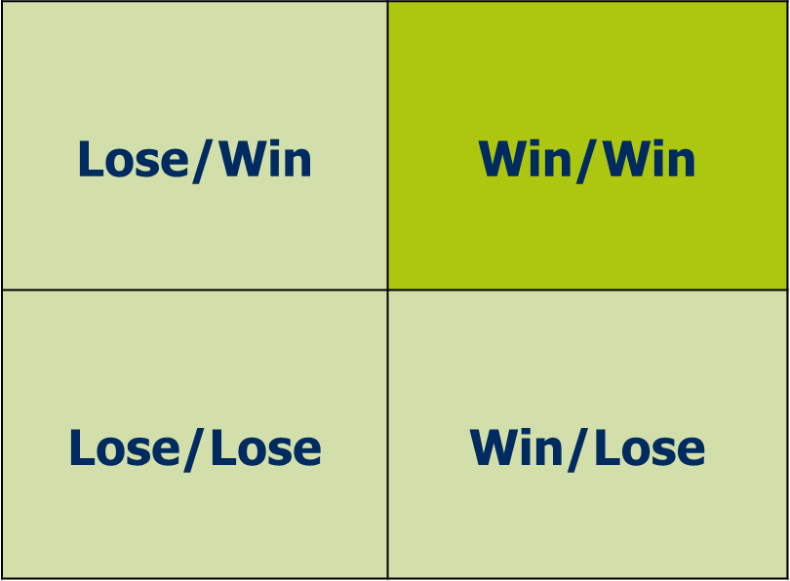

**Courage**

**Consideration**

Low

Low

High

High

High